(a)

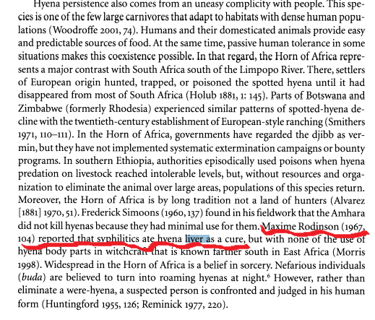

(b) Ritual and Belief in Morocco:, Volume 2
By Edward Westermarck
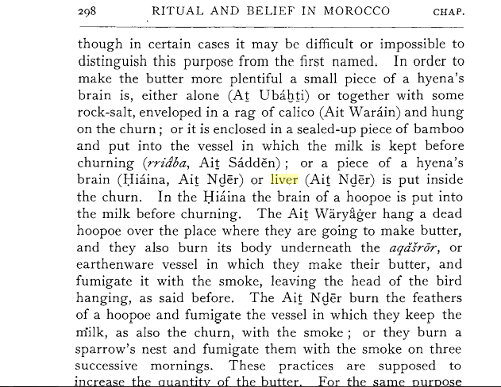

(c) http://www.wayward.com/animal.htm
If, again, this preparation is kept till it is old, it will be all the better for improving the sight, due care being taken to preserve it in a box of Cyprian copper; they assert also that it is good for the cure of argema, eruptions and excrescences of the eyes, and marks upon those organs. For diseases of the crystalline humors of the eyes, it is recommended to anoint them with the gravy of the hyena's liver roasted fresh, incorporated with clarified honey.
We learn also, from the same sources, that the teeth of the hyena are useful for the cure of toothache, the diseased tooth being either touched with them, or the animal's teeth being arranged in their regular order, and attached to the patient; that the shoulders of this animal are good for the cure of pains in the arms and shoulders.
The teeth, extracted from the left side of the jaw, and wrapped in the skin of a sheep or he goat, are an effectual cure for pains in the stomach; that the lights of the animal, taken with the food, are good for coeliac affections; that the lights, reduced to ashes and applied with oil, are also soothing to the stomach; that the marrow of the backbone, used with old oil and gall, is strengthening to the sinews.
The liver, tasted thrice just before the paroxysms, is good for quartan fevers; that the ashes of the vertebrae, applied in hyena's skin with the tongue and right foot of a sea-calf and a bull's gall, the whole boiled up together, are soothing for gout; that for the same disease hyena's gall is advantageously employed in combination with stone of Assos; that for cold shiverings, spasms, sudden fits of starting, and palpitations of the heart.
It is a good plan to eat some portion of a hyena's heart cooked, care being taken to reduce the rest to ashes, and to apply it with the brains of the animal to the part affected; that this last composition, or the gall applied alone, acts as a depilatory, the hairs being first plucked out which are wanted not to grow again; that by this method superfluous hairs of the eyelids may be removed.
The fumes of the burnt fat of this animal will put serpents to flight, they say; and the jawbone, pounded with anise and taken with the food, is a cure for shivering fits. A fumigation made therewith has the effect of an emmenagogue; and such are the frivolous and absurd conceits of the professors of the magic art, that they boldly assert that if a man attached to his arm a tooth from the right side of the upper jaw, he will never miss any object he may happen to aim at with a dart.
The palate, dried and warmed with Egyptian alum, is curative of bad odors and ulcers of the mouth, care being taken to renew the application three times. Dogs, they say, will never bark at persons who have a hyena's tongue in the shoe, beneath the sole of the foot. The left side of the brain, applied to the nostrils, is said to have a soothing effect upon all dangerous maladies either in men or beasts.
They say, too, that the skin of the forehead is a preservative against all fascinations; that the flesh of the neck, whether eaten or dried and taken in drink, is good for pains in the loins; that the sinews of the back and shoulders, used as a fumigation, are good for pains in the sinews; that the bristles of the snout, applied to a woman's lips, have all the effect of a philter; and that the liver, administered in drink, is curative of griping pains and urinary calculi.

(d) http://www.ibtimes.co.uk/hyena-meat-extinction-saudi-arabia-consumption-halal-481755

Hyena Burger? Saudi Taste for Wild Meat Threatens Species Extinction

Consumption and hunting of hyenas is threatening the species' survival
- 
By Hannah Osborne
June 21, 2013 15:12 BST
- 1
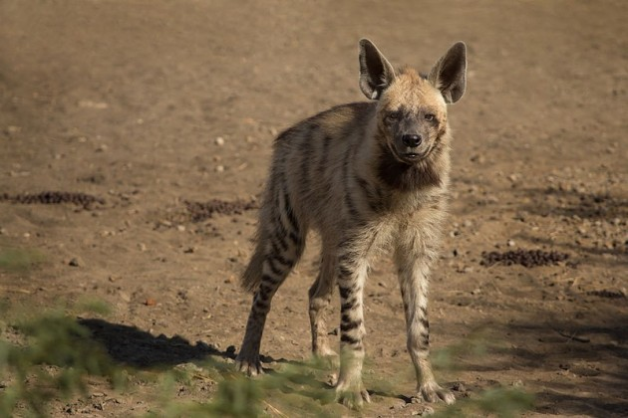
Hyena meat is considered a delicacy in Saudi Arabia (Reuters)
Hyenas are being threatened with extinction because people across Saudi Arabia have developed a taste for the wild animal's meat.
In 2008, the International Union for Conservation of Nature (IUCN) listed the striped hyena as "near threatened" as its population was estimated to be below 10,000.
They are native to north and east Africa, the Middle East and central Asia. IUCN said that humans posed a major threat by poisoning the animals and hunting them for use in traditional medicines.
"There is also illegal trade in skins, and body parts for use in traditional medicine, and they are often kept in cages for display purposes," the organisation said.
"The species is commercially hunted in Morocco for use in traditional medicine, with various parts being used, especially the brain, and may fetch very high prices. Hunters may travel hundreds of kilometres to capture this species."
However, hyenas are now under threat from people using them as a food source in Saudi Arabia.
Under Islamic law, the meat of hyenas is considered halal, or lawful, even though the animal is wild.
Aphrodisiac
Saud Bin Mus'id al-Thubaiti, a member of the teaching staff at the faculty of Shariah at Umm al-Qura University, told the Saudi Gazette: "Whoever is in the state of consecration Ihram and hunts a hyena will have to slaughter a sheep as a penalty. As for other forbidden animals and birds, there is no penalty if a Muhrim hunts them."
Eating hyena meat was also permitted by Al-Shabaab militants in southern Somalia last August. A resident of Kismayo told Hiiraan Online that since it was approved, restaurants have begun selling it and the price has risen so much so that it is now only affordable to wealthy people.
Hyena meat is also eaten in areas of Pakistan and Iran, where it is also considered halal.
Speaking to the Gazette, Abdulraheem Al-Otaibi said he loved the taste of the meat and championed its medicinal benefits: "Hyena meat has a unique taste and has an effect that is stronger than well-known aphrodisiacs."
The newspaper said hyenas were being widely consumed by Saudis and were considered "a unique and scrumptious delicacy".
Hunter Nasser Al-Thubaiti explained that he killed the animals and removed their innards immediately to prevent toxins leaking from the offal into the meat.
Ahmad al-Bouq, director of the Wildlife Research Centre in Taif, said the threat to the species was dire.
"Hyenas are threatened with extinction in the kingdom," Bouq said. "They are classified among the big beasts of prey, aside from the Arabian tiger and lynx."

(e) http://www.saudigazette.com.sa/index.cfm?method=home.regcon&contentid=20130621170664



Saudis gorge on hyenas as they face extinction

Saudi Gazette report

TAIF — The thought of hunting and eating hyena might send shivers down the spine of some, but not Saudis.
Considered a unique and scrumptious delicacy, heynas are found in small numbers here but are largely consumed by Saudis.
And while people continue to gorge on the beast’s meat, they seldom realize that they are on the verge of being extinct.
According to a report published in Al-Watan last week, hyenas are on the list of animals threatened with extinction.
Ahmad Al-Bouq, director of the Wildlife Research Center in Taif, said: “Hyenas are threatened with extinction in the Kingdom. They are classified among the big beasts of prey, aside from the Arabian tiger and lynx.”
The ruling behind eating hyena meat in Islam is permissible. Dr. Saud Bin Mus’id Al-Thubaiti, member of the teaching staff at the faculty of Shariah at Umm Al-Qura University, and a former professor, said that the Prophet (peace be upon him) has forbidden eating the meat of beasts of prey that have canine teeth and birds that have claws. However, he permitted eating hyena meat.
Al-Thubaiti further said that hyena meat is halal although it has canine teeth. “Whoever is in the state of consecration Ihram and hunts a hyena will have to slaughter a sheep as a penalty. As for other forbidden animals and birds, there is no penalty if a Muhrim hunts them.”
Nasser Al-Thubaiti said he has hunted hyenas several times. After he kills the animal, he immediately removes the viscera from his abdomen.
He said that this is usually done by hyena hunters so that the offal does not emit their toxins into the meat and pollute it.
Jaber Al-Otaibi said he hunts hyenas when he encounters them during a hunting trip. He presents them as a gift to his friend who eat hyena meat, but he himself has never tasted the meat in his life.
Abdulraheem Al-Otaibi said he loves eating hyena meat, as it has a special taste which distinguishes it from other animals. “Hyena meat has a unique taste and has an effect that is stronger than well-known aphrodisiacs.”
He said people are disgusted by hyena meat due to the shape of the animal, and the fact that it is carnivorous.
On the other hand, Saudi national Ibrahim Al-Otaibihe expressed his disappointment and astonishment at people who eat hyena meat, as it feeds on dead animals.
He said that once he attended a dinner party where hyena meat was served, but he didn’t take a single bite while others voraciously ate.
Meantime, Dr. Mundhir Abdullah, a consultant internist, said there no scientific study has proven that hyena meat is beneficial to man’s health, or if it harms anyone.
He also said that eating hyena meat does not cure any disease, as some people might believe.
However, he advised that it’s better to avoid it as it feeds on animal carcasses.
Other reasons threatening the extinction of hyena are that some people kill or poison them as they threaten the lives of human beings and livestock.

(f)
http://somalilandpress.com/islamists-authorise-hyena-meat-in-southern-somalia-33433

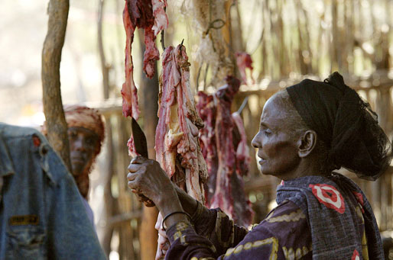
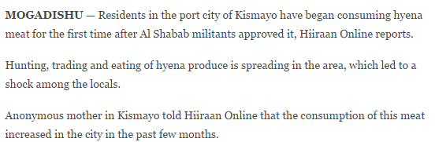

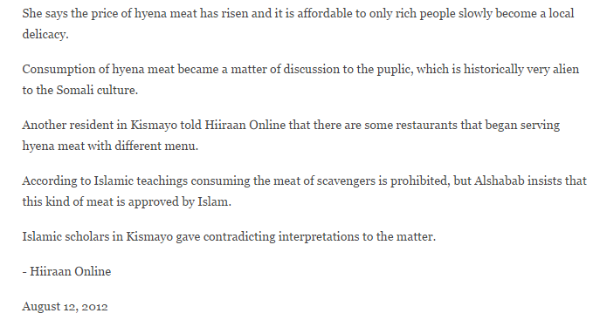

(g)
http://medical-dictionary.thefreedictionary.com/Hyaenanche+globosa

Hyaenanche globosa

South African plant in the family Euphorbiaceae. Contains a toxic substance hyaenanchin. Called also hyena poison.

(h) http://books.google.co.ug/books?id=yvMfAQAAIAAJ&q=hyena+poison&dq=hyena+poison&hl=en&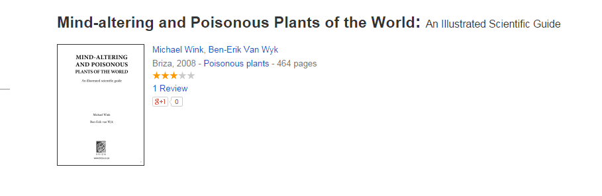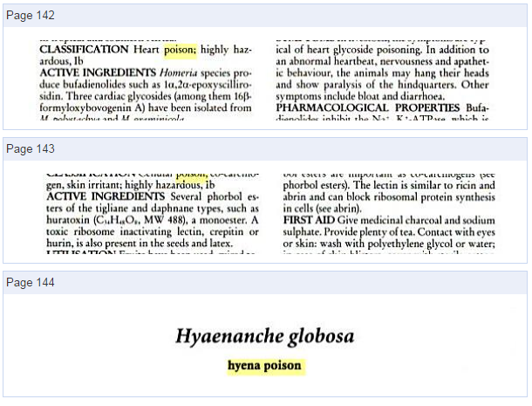
(i) http://www.plantzafrica.com/planthij/hyaenancheglob.htm
Hyaenanche globosa | (Gaertn.) Lamb. & Vahl
Family : Picrodendraceae (formerly Euphorbiaceae)
Common names: hyaena-poison (Eng.); gifboom, wolwegifboom, wolweboontjie, boesmansgif
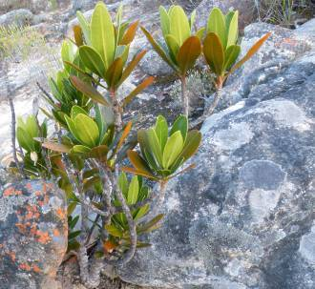
A young gifboom growing among sandstone rocks.
The Gifboom is a large evergreen fynbos shrub or small tree endemic to the Gifberg of the northern Bokkeveld Escarpment just south of Vanrhynsdorp (northern part of the Western Cape). The fruits are highly toxic and were formerly used by the San for their arrows and also by local farmers to kill hyaenas.
Description
Erect to spreading, large evergreen shrubs 2–4 m tall and up to 8 m in diameter, often multi-stemmed, due to occasional fires. The sexes are on separate plants. The bark is grey and fissured vertically. Leaves leathery, ascending, simple, in whorls of four, 85–145 x 18–37 mm, shaped like a lance to elliptical, slightly hairy at first, the older leaves becoming hairless and shiny with age. The upper surface is dark green, lower surface light green, nerves slightly visible, except for the quite conspicuous yellowish green midrib. The margin of the leaves is entire, straight to slightly undulating, the base is wedge-shaped (cuneate) and the end is usually blunt (obtuse). The leaves of female plants tend to be smaller than in male plants and the ends taper to an acute point, often ending in a small sharp hard point (mucronate). Male as well as female plants have small, inconspicuous red flowers without petals. The male flowers are borne in conspicuous dense clusters up to 30 mm long. They have five or six irregularly overlapping (imbricate) sepals. The bottom of the male flower (receptacle) is broad, bearing numerous stamens with large, erect anthers producing copious pollen. Female flowers are usually solitary, with 6 sepals in 2 whorls. The ovary is hairy, bearing 3 to 5 large fused styles up to 7 mm long and free for 4 mm. Fruit a 3–4-lobed rounded capsule about 2,5 mm in diameter. Seeds are large, black and shiny (up to 6 per capsule).
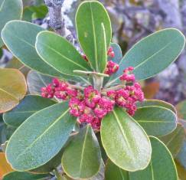 | 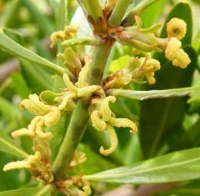
Close-up of the male flowers of  Hyaenanche globosa, just before opening. | Close up of the female flowers of  Hyaenanche globosa
Conservation status
Although not taken up in the Red List of South African plants (Raimondo et al. 2009), it is a rare shrub confined to a small section of the northern Bokkeveld.
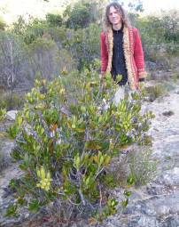
A plant growing wild on the Gifberg. Note the rocky habitat.
Distribution and habitat
The gifboom is confined to the northern Bokkeveld Escarpment Mountain Plateau. This includes mainly the Gifberg and Matsikammaberg. These mountains consist of Bokkeveld Sandstone Fynbos (Mucina et al. 2005). The habitat is very rocky and with shallow soil, poor in mineral content. It is derived mainly from quartzitic sandstone of the Cape Supergroup (Table Mountain Group). The plants grow in open, dry fynbos vegetation, sharing its habitat with other fynbos tree and shrub species such as Euclea linearis, Leucospermum calligerum, Paranomus bracteolaris, Maytenus oleoides, Olea europaea subsp. africana, Protea glabra, Protea nitida, Heeria argentea, Osyris compressa, Diospyros glabra and Phylica oleifolia. Smaller succulent plants include Adromischus hemisphaericus, Braunsia maximiliani, Euphorbia loricata, Crassula dejecta, C. atropurpurea var. watermeyeri, C. brevifolia, C. ericoides, C. tomentosa var.tomentosa, Oscularia alba, Tylecodon ventricosus and Cotyledon orbiculata. Summers are hot with cooler winters (frost is light, during winter). Rainfall occurs mainly during winter (cyclonic cold fronts), ranging from 300 – 500 mm per annum.
Derivation of name and historical aspects
The local common name gifboom (gif = poison, and boom = tree) pertains to its toxic attributes and the name Gifberg (gif = poison, berg = mountain) is derived from the common name of this plant.
The gifboom (Hyaenanche globosa) was first documented by a number of prominent European botanists visiting the Cape during the seventeenth and eighteenth centuries. The first to come across this plant was the Van der Stel expedition, en route to the Koperberg, Namaqualand in 1685 (Smith 1966). Carl Thunberg and Francis Masson collected specimens of the plants on their journey to the north in 1774. Shortly after, in 1779, William Paterson, Colonel Gordon and Sebastian van Rheenen also documented the plants on the Gifberg.
The plant was first named by the German botanist Joseph Gaertner (1732–1791) in the eighteenth century as Jatropha globosa. Unaware of Gaertner's name, Thunberg created the nameToxicodendron (literally meaning poison tree), however, this appropriate name could unfortunately not be upheld, as it had been already created by Miller in 1754 for another group of trees in the Anacardiaceae.
Aylmer Lambert (1761–1842) a British botanist, researched the plant and realized it should get a new generic name. He created the genus name Hyaenanche (after its use by farmers to kill hyenas) in 1799 which is still in use today. According to C.A. Smith in Common names of South African plants (1966) Beutler was the first person in 1752 to record the name “wolwegif” (wolf = wolf, gif = poison). This common name was also recorded by Thunberg.
Ecology
The gifboom flowers mainly during late spring (October to November). The male flowers are very attracti ve and conspicuously red. As the anthers open, pollen is spontaneously released, and dispersed by wind. The male flowers produce pollen in profusion, and at the touch of a flowering branch, a dust cloud of pollen can be clearly observed, so typical of wind pollinated plants. Female flowers are inconspicuous and give rise to rounded fruits, which are green at first, brownish yellow when mature.
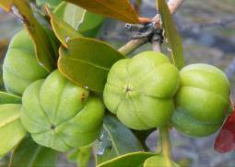 | Hyaenanche globosa mature fruit,  sometimes lobed.
One can ask the question, why the conspicuous red colour of the male flowers, when the plant is clearly pollinated by wind? The reddish colour is commonly observed in young leaves or fruits which mature, and in leaves under stress. This is commonly observed in many succulent plant species. This reddish colour is a result of the producti on of anthocyanins. In young leaves the red pigment protects the soft tissue from excessive radiation from the sun. However in fruit, such as a red peach, the function is to attract the right dispersal agents. The function in the male flowers of Hyaenanche is probably also to protect the young male flowers from excessive radiation.
Uses and cultural aspects
The fruits are highly toxic and were formerly used by farmers to poison hyenas. Lambert (1797) who created the genus name Hyaenanche, had the following comment on its cultural uses, and I quote him:
“This shrub grows about two hundred miles from the Cape, in a rocky soil, in a single spot, on Wind-Hook Mountain near the Elephants River. A farmer lives there who collects the fruit, by which he makes profit of about 20 pounds per annum, selling it for the purpose of poisoning hyenas. The fruit is pounded into a powder and administered in the same manner as Nux Vomica. The powder is put into the carcasses of lambs, which are laid where the hyenas are known to come. By eating its flesh they are infallibly destroyed. The plant flowers and bears fruit annually in the stove of the right honourable, the Earl of Tankerville, at Walton, the only place it has yet flowered in this country, and I believe in no other collections in England. Our figure of the female was drawn from the plant in his lordships stove in 1795; the male from a specimen very obligingly communicated to me by Mr. F. Masson”
According to Watt & Breyer-Brandwijk (1962) the seed of Hyaenanche was used both by bushmen for their arrows, and well as farmers to poison carcasses with the purpose of destroying hyenas. Henkel first isolated the toxic principle from the seed and seed coat. This was named hyaenanchin (C15H18O7) and he found it to be neither an alcaloid nor a glucoside.
The farmer Dave Schlebush from the farm Sewefontein on the Matsikamma Mountain has observed that sheep do nibble on the leaves at times without any ill effect. Dr E.P. Phillips stated that the rocky pools filled by rain water and covered in fallen leaves; do have a negative effect on cattle.
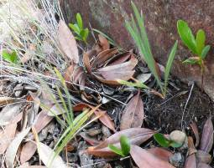 | Young seedlings of the gifboom on the Gifberg
Growing Hyaenanche globosa
Hyaenanche globosa is best grown in dry fynbos gardens (Van Jaarsveld 2010). They require full sun and sandy, mineral-poor soil for best results. This small tree is ideal for summer dry gardens and rockeries. The gifboom is easily propagated from seed.
Seed was collected by the author during 1977 and four years after sowing in the Matthews Rockery at Kirstenbosch National Botanical Garden the resulting plants were planted out. Two of these plants (male and female) have now (2011) reached a height of about 3,5–4 m. The plants first came into flower in 2009, and again in 2010 and 2011. Good seed set was obtained in 2011. The seed takes about a year to mature.
Autumn is the best time for sowing, as it is the beginning of the rainy season. Sow in a standard seed tray. Use a standard well drained, slightly acidic soil mix (2 parts sand, 1 part loam, 1 part compost). Place the seed on the medium and cover lightly with sand. It is best to keep the seed tray partially shaded. Germination commences within about three weeks of sowing. Plants should be first planted in small containers, to be transferred to larger trays. Add organic fertilizer and water well during its growing period.
Plants are relatively disease-free, however they succumb rapidly to Phytophthora.
References and further reading
- Gaertner, J. 1790. De fructibus et seminibus plantarum. 2: 122, t. 109, fig. 3.
- Gunn, M. & Codd, L.E. 1981. Botanical exploration of southern Africa. Balkema, Cape Town.
- Helm, N. 2004. The vegetation of Matsikamma Mountain with some comments on endemicity. Plant Life 30: 5–16.
- Hutchinson, J. 1920. Toxicodendrum in Flora Capensis 4, 2: 408,409. L. Reeve & Co., Ltd., London.
- Lambert, B. 1797. Descriptions Cinch 52, t. 10.
- Leistner, O.A. (ed.). 2000. Seed plants of southern Africa : families and genera. Strelitzia 10. National Botanical Institute, Pretoria.
- Mucina, L. & Rutherford, M.C. (eds) 2006. The vegetation of South Africa, Lesotho and Swaziland. Strelitzia 19. South African National Biodiversity Institute. Pretoria.
- Raimondo, D., Von Staden, L., Foden, W., Victor, J.E., Helm, N.A., Turner, R.C., Kamundi, D.A., Manyama, P.A. (eds) 2009. Red List of South African plants. Strelitzia 25. South African National Biodiversity Institute, Pretoria.
- Smith, C.A. 1966. Common names of South African plants. Memoirs of the Botanical Survey of South Africa No. 35. Department of Agricultural Technical Services. Botanical Research Institute.
- Van Jaarsveld, E.J. 1982. Plantegroei van die Gifberg met spesifieke verwysing na bome, struike en die gifboom. Trees in South Africa. Journal of the Tree Society of South Africa 34: 1 & 2, 10–27.
- Van Jaarsveld, E.J. 2010. Waterwise gardening in South Africa and Namibia. Struik, Cape Town. 2010.
- Watt, J.M. & Breyer-Brandwijk, M.G. 1962. The medicinal and poisonous plants of southern and Eastern Africa. E. & S. Livingstone Ltd., Edinburgh and London.

